**AR4th : An Augmented May 4th Experience**

**8. Design Document**

The augmented May 4th experience project is designed to immerse and engage users as they journey through the events of May 4th. The experience will include both physical and digital components and invite users to view perspectives of the Kent State Massacre through the lens of augmented reality using historical imagery, audio and related experiences that highlight humanitarian struggles. As the tour is initiated, participants will follow a trail through the Kent State Campus that chronicles the events of May 4th. Seven AR “hotspots” along the path will transport the audience to that fateful day via the use of images overlaid on present day Imagery as well as audio from the time period. Users will effectively view the events from the same physical space and time through pictorial and aural historic place restoration. Each hotspot will focus on an important aspect of the events and underpin the humanities themes. The cross-platform online experience will include a custom AR interface utilizing global position (GPS) data, as well as gyroscopic sensor feedback to overlay historical photos over the users’ device viewpoint and trigger archived sound clips creating a window to the past. Each hotspot will include additional media and links to enhance and engage the user in the underlying humanitarian values through different perspectives and viewpoints.

The augmented May 4th experience is a novel and aspiring proposal and herein we outline a project plan to develop the AR platform and generate a fully functioning prototype experience. As the product is developed we will focus on: A) Providing a complete and accurate historical account of the tragic events, B) Educating and engaging users with humanitarian narratives, C) Incorporate an effortless and accessible AR user experience. A significant portion of the prototyping will include the evaluation and redevelopment of the platform. In the sections below we provide the overall architecture of the multisensory experience with exploratory examples of included media. Through our accomplished team and external advisory board themes will be strengthened and composed throughout the grant duration and the AR experience will be iteratively evaluated and refined.

**1) Narrative treatment**

The core narrative proposed in the current proposal will be led by multiple humanities topics according to a chronological progression. Despite the core focus is on the Kent State Massacre, the media experience will stage multiple connections to other themes for telling a broader story. Therefore, those events and their ties become a way to address several History-related topics, among which the Complex Landscape of History, Student Protests of the 1960s, First Amendment Rights, Excessive Use of Government Force, and Memory and Commemoration.

May 4th events will remain the *fil rouge* to follow. However, each hotspot will work as a gate to expand users’ perception of what that day meant and still means for United States and beyond. The main objective is to transform the targeted actions (from protests to the burned ROTC building) into metaphors of the wide phenomena and processes that influenced (and still influence) American society, from student protests to memory and healing. Therefore, relevant efforts have been done in sketching a) key steps an b) occurrences and implications of May 4th through such a wider lens.

The result is a linear but rich narration through the campus. May 1, 2, and 4th dynamics will inform the reference structure of the media experience for staging a clear and intuitive progression, while further content will be provided to frame them within the national context and according to their long-term impact. The resulting outcome will harness AR for triggering two different narrative effects:

1) Situated narration: combining present and past for a situated narration, in which distant events are displayed “here and now” for eliciting immersion and engagement. This solution can be described as a technology-mediated place restoration, which increases the user’s predisposition to learn and be involved.

2) Environmental narration: keep the user’s attention to the real environment by providing supporting and not overwhelming inputs (e.g., overlapping images, environmental sounds and audio), which is why AR was selected as reference technology. Therefore, the KSU campus will speak *by itself* rather than relying on a virtual reality, which risks to make the whole path unreal and disjointed.

The challenge in dealing with History (and especially when traumatic events are targeted) is the spatial and temporal distance from the topics taught. AR will allow us to develop a non-intrusive narration able to add multiple layers of meaning to the real place without *losing* nor *weakening* it. Regarding the specific topics addressed, the themes of Complex Landscape of History and Memory and Commemoration (which represent the project’s main orientations) will be reached in almost all the hotspots. Student Protests of the 1960s, First Amendment Rights, and Excessive Use of Government Force will be reached by specific ones due to their peculiarity; they will work to set premises, development, and conclusions of May 4th events respectively – the May 4th memorial and its meaning in terms of memory and healing will be the last step of this journey, indeed. In addition, they will help the user in understanding the national scale of those days. These topics will be handled using multiple media, from environmental sounds and voices to historical pictures and external URLs. The goal is to increase (and then exploit) immersion while the Humanities topic is delivered; stories are effective learning tools, but they work best when *authentic* and AR can strengthen such an interplay. Regardless, the overall experience will be aligned with the aforementioned environmental narration: the supportive content will be straightforward and functional without overloading users with too much information (more materials are available at the May 4th Visitor Center).

**2) User Experience**

*A Physical Path across Campus:*

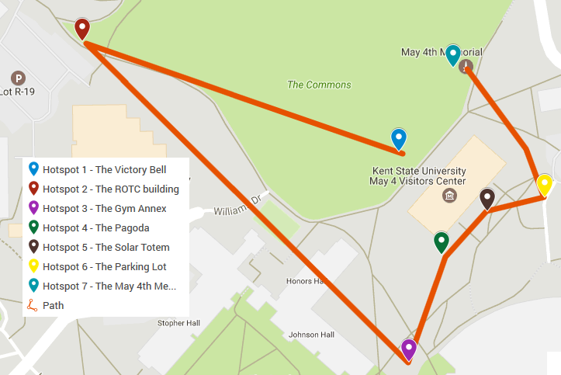 At the heart of the Augmented May 4th Experience is the ability to physically retrace and digitally experience the events across Kent’s campus by visiting historically relevant stops to support the underlying narrative. At each stop along the tour users are immersed in media content depicting the events via cellular phone interaction with the AR website. Based on the important themes and our available historical media we have selected the path of approximately .4 miles across Kent’s campus illustrated in the map below.

The outlined path relies on 7 “hotspots” selected by their historical meaning and thematic significance. The Victory Bell will represent the starting point, while the May 4th Memorial the end. The hotspots, the narrative rationale for choosing them, and the related Humanities concepts uncovered are depicted below:

**1.** **Victory Bell**   
On May 1, 1970 a group of approximately 500 students gathered at the Victory Bell to protest President Nixon’s announcement of the Cambodian Incursion the previous night.  After a weekend of turmoil off campus and on, an estimated 2000-3000 students and spectators gathered that Monday to protest the Vietnam War and the presence of the Ohio National Guard on campus.

*Theme(s) Addressed: First Amendment Rights;* *Student protests*

**2. Site of the ROTC Building**On Saturday, May 2, 1970 a large crowd of students gathered at the ROTC.   When local firemen arrived to extinguish the flames, protesters tried to block their path and cut their hoses and in response the National Guard were called on campus to restore order. It is still unknown who set the ROTC building on fire.

*Theme(s) Addressed: Student protests;* *Complex Landscape of History*

**3.  Gym Annex**On May 4, 1970 members of the Ohio National Guard kneeled and pointed their weapons at Alan Canfora as he waived his black flag of protest in one of the most iconic images from the shootings.   In 1977, the site of the practice football once again became contested ground. To protest the proposed building of an annex to the gymnasium, more than 130 people camped on the site in what is now known as Tent City. After several months, the University ordered the arrests of the protestors -- including the family members of the victims -- and proceeded with the construction that forever altered the site.

*Theme(s) Addressed:* *Healing and Memory;* *Complex Landscape of History*

**4.  Pagoda**The Pagoda was originally built as a temporary art installation by students in the Architecture Department. However, on May 4, 1970 it became a tragic symbol.  After gathering in the practice football field, 29 out of a group of 77 members of the Ohio National Guard turned in unison, shooting 67 shots for 13 seconds, killing four students and wounding nine others.

*Theme(s) Addressed: Excessive Use of Government Force; Healing and Memory;* *Complex Landscape of History*

**5.  Solar Totem #1**Originally designed in the summer of 1967 by Don Drumm as part of National Defense Education Institute on “Creativity in Arts” with industrial art teachers from across the nation, Solar Totem #1 was pierced by a bullet from the National Guard during the May 4 shootings.  When asked by the University to repair the structure, Drumm refused. He later remarked that the National Guard had created their own memorial.  During the annual commemoration, the structure is often covered with chalked messages of hope and remembrance.

*Theme(s) Addressed:* *Healing and Memory;* *Complex Landscape of History*

**6.  Prentice Parking Lot**All four of the students killed and all but one of the students wounded during the May 4 shooting where located in or around the Prentice parking lot.  Markers now stand in the spots where Sandy, Allison, Bill, and Jeff were killed.

*Theme(s) Addressed: Excessive Use of Government Force; Healing and Memory; Complex Landscape of History*

**7. May 4 Memorial**After years of controversy, resulting in a 75 percent reduction of the original proposal, the May 4 Memorial was dedicated in 1990. It was the first official memorial to the victims of May 4 and during the dedication ceremony, Governor Celeste offered the very first government apology for the shootings.

*Theme(s) Addressed: Healing and Memory; Complex Landscape of History*

***General Website design and Structure***

The interactive and augmented experience will be designed from the outset with cross-platform compatibility in mind. Running within the browser and built using new web specifications, Android, Microsoft and Apple devices will natively work with the online experience. Participants will connect to the website homepage housed on Kent State’s servers and be greeted with a prompt to begin the tour or view the map of the hotspots. The homepage background will be a slideshow of relevant images and will include buttons to 1) Begin the tour, 2) View the map of the seven hotspots, and 3) Make the website full screen (center bottom) 4) An information icon to view a brief synopsis of the project (bottom right).

*Homepage Mockup****:***

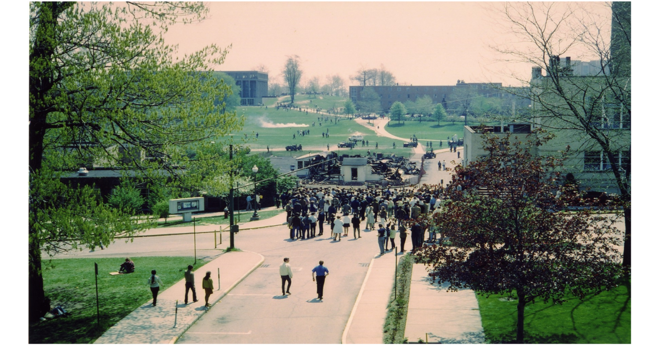

***Begin Tour***

***View Map***



***An Augmented May 4th Experience***



***🡪 start the tour***

* ***Map with clickable locations***

From the homepage the user can initiate the guided tour using the “Begin Tour” button or view the map image via the “View Map” button. Either selection can be used to access the AR content. If the use taps “View Map” the map interface loads with a red X (updated based on sensor data) representing the current position. The user may click on a hotspot to load the relevant AR media, or click the return icon to return to the previous page (either the main menu or the AR hotspot interface depending on where the map was accessed)

*Map Interface Example*



**X**



**You Are Here**

**CLICK A HOTSPOT TO VISIT**

Return

If a tour is initiated, the users camera display is activated and depending on whether the user is at the starting geolocation either: 1) an arrow is overlaid on the camera feed pointing to the real world direction of the first (or next) hotspot location and updated based on user positional sensor data, or 2) In the event that the participant is located within 2 meters of the a hotspot the AR interface is loaded for the first location.

Navigation Buttons

**Live Camera Feed**

Overlaid Historical Image

**1**

**2**

**3**

**4**

**5**



Return

Button



Map Button



Audio Controls

*General Layout of Each hotspot*



Next Hotspot Button

**6**

**Hotspot Title**

Each hotspot will embed an historic image - overlapping the real camera based visual through the phone screen and initiate the hotspot specific environmental audio sample to play automatically, also clicking the first navigation button initates additional audio. Users may return to the previous page, or access the map via as well as control audio via the on screen icons. In addition, the following types of content linked through navigation buttons provide more details over events at the specific location and reinforce the underlying humanities themes.

1) Day (e.g., May 1, May 4): Environmental sounds.

2) Remembering (gallery): pictures of memorials and commemorations about May 4.

3) Context (gallery): related images from the same time period.

4) I was there: voices and memories by witnesses

5) Audio narration from the walking tours (audio) - complete and summarized.

6) External links: URLs to further references and materials.

Once the user is finished tapping the next hotspot button prompts the user with an arrow overlaid on the live video pointing to the next hotspot. As the user is within 2 meters of the next hotspot the relevant AR experience is loaded. Audio content will be captioned for users with hearing impairments.

*Mock up Layout of hotspot 1:*

****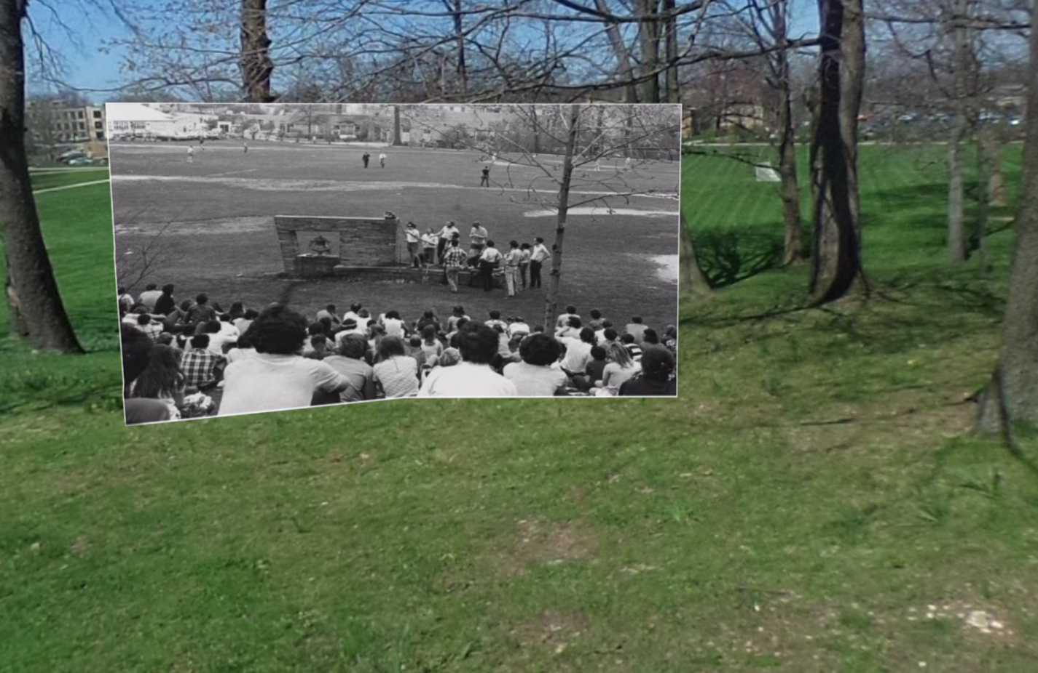

***May 1 and May 4***

***Remembering***

***I was there***

***Walking tour***

***Links***



**HOTSPOT 1: The Victory Bell**

***Context***

The example mock up hotspot here displays the historical images of the Victory Bell gathering virtually placed in the correct position on the real world camera data transporting the user through the lens of AR. As the interface is loaded audio (e.g., the bell ringing) is activated and plats. As the user clicks the navigation buttons on the right of the screen additional content loads over the interface to allow the user to navigate the information and view images and additional audio.

For HOTSPOT 1: The Victory Bell, the following provides examples that will be included for each content area at this specific hotspot.

**1) May 1 and May 4**

Environmental sounds – e.g., the bell ringing, students’ voices.

**2) Remembering**

Images from the Annual Candlelight March and Commemoration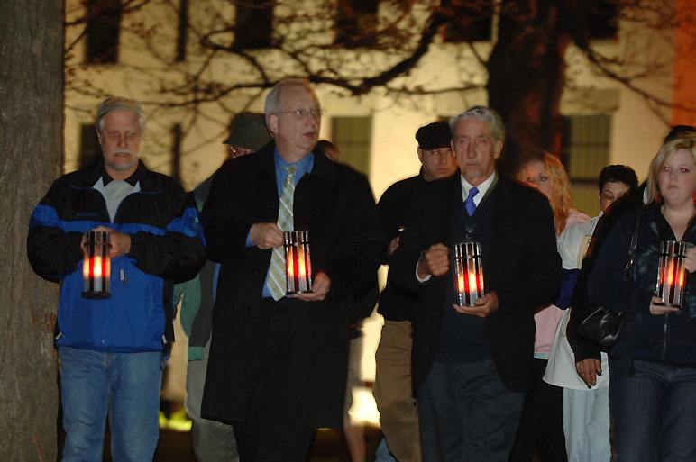

**3) Context**

Images from other protests of the Cambodian Incursion.

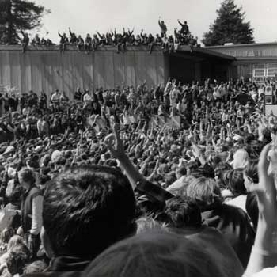

**4) I was there**

* Clips from eyewitness accounts

**5) Walking tour**

* First chapter of the walking tour about May 4TH narrated by Julian Bond.

**6) Links: External URL’s**

* First Amendment

<https://en.wikipedia.org/wiki/First_Amendment_to_the_United_States_Constitution>

* President Nixon's Cambodia Incursion Address

https://www.youtube.com/watch?v=3cAAnoqmksg

**Navigating the AR Experience**

Essentially two forms of navigation exist in the current project: Physical and Digital. Physical navigation includes following the trail across campus and visiting each hotspot to view the events of the past through the lens of AR. Working with the university architects we will erect a series of signposts directing participants to the initial hotspot on campus. Hotspots will be identified by the presence of a clearly labeled signpost (with a light) and a printed decal on the ground indicating the geolocation at which AR content can be accessed. The ~.4 mile trail to be followed will be identified by a series of arrow decals on the pavement (or signage where appropriate) pointing the way to the next clearly visible hotspot. Digitally we have two strategies for aiding navigation. Firstly the included map with a real-time update of the users’ location will provide a simple means to locate and follow the trail. In addition, as indicated above, the user can also follow the onscreen arrow overlaid on real-time camera data pointing to the location of the next physical hotspot. Once at the hotspot the user can point their device and locate the virtual view of past event. Both positional and gyroscopic data will be captured by the website to identify the gaze location and the imagery overlaid as appropriate. This data will be utilized to place the image in the correct position on screen as well as point the arrow toward the next hotspot.

**Approach to Interaction**

As emerged above, the interactive system will be led by the core concepts of authenticity and simplicity. Content will be delivered in a straightforward way and without overwhelming the user with useless details. The goal of the present project is indeed to increase interest about May 4th and beyond via an AR place restoration rather than staging an intensive flow of information. AR mobile consumption is characterized by dynamicity and context-awareness, and the final prototype will be developed accordingly. Final users will move thorough the KSU campus following a clear roadmap, discover its points of interest and unpack the different layers of meaning hidden by all these years. The real environment will be always at the core of the media experience for strengthening the desired informal learning and embodied cognition, while the May 4th Visitor Center will serve as an essential source in-situ for additional materials and stimuli. The extended walking tour and the external links are the only exceptions of such a non-intrusive approach; however, they will allow to deepen the topics addressed further and their use will be at users’ discretion.

In order to maximize the engagement, different media are included to satisfy subjective preferences in *living* and perceiving history. Personalizing the experience is a crucial step to involve broader audiences and building an effective application. However, each sense will be stimulated by one specific input at a time avoiding sensorial overloads (i.e. multiple pictures or multiple sounds at the same time), which might weaken immersion and focus.

In conclusion, the resulting interaction will be *transparent* and *ancillary*, with an intuitive switch between screen and reality and between present and past. AR will function as a smart guide, providing insights when they are needed and in the most productive way possible, without making history just a *virtual memory* nor confusing users with blurry indications and associations.

**3) Technical Specs:**

**Physical Specifications**

Physically the May 4th experience exists as a series of sign posts and decals adhered to the pavement Sign posts will be located at 1) strategic locations on campus to direct participants to the first hotspot, and 2) The seven identified hotspots to help users navigate the path. Pavement decals will be placed at the location of each hotspot to indicate where the AR experience is accessible including the address of the website and hotspot name. In addition decals will be placed at strategic points along the walking path to provide directional prompts.

**Digital Specifications**

*Software Architecture:*Generally speaking the specifications of the software center around a website designed to run across platforms (Apple, Android, Windows) within the browser. All tools utilized in the development of the project will be fully developed open source libraries and freely available for use. The website will be using the latest HTML5 web features in order to provide a seamless augmented reality experience on any device without the need for download of an app from an external store. HTML5 has simple access to acquire geolocation, deviceorientation and devicemotion events that will be heavily used in the current project. Geolocation will be used to identify whether a participant is located within a hotspot to initiate the content delivery as well as provide user location data on the map. Device motion and device orientation events are utilized by the underlying libraries (described below) to identify the direction that the cellphone is facing, and or rotated, to adjust the position of the rendered content. The website will render the historical images, directional arrows, and navigational components using javascript programming of the ThreeJS[1] library for drawing interactive 3D content utilizing WebGL[2]. The JSARTOOLKIT[3] , a programming toolkit for rendering augmented reality with ThreeJS, will be utilized to overlay rendered content on live video from the users’ phone camera. The extensive tutorials and simple programming interface are well suited to complete the necessary tasks efficiently and cross-platform. The use of mature, reliable and efficient cross-platform programming interfaces will ensure the project is both compatible and completed in a timely manner.

*Included content:*

The completed project will include images, audio, video and sourced materials from varied local and external websites. Our model means that the newly developed AR experience will pull from existing served sources and the only materials requiring serving will be the website itself. Further details about internal and external content and the sources are below.

*Local:* Local content will include the developed website as well as media content locally managed and housed on Kent States servers.The new website will exist as a series of HTML pages, icon graphics and javascript files. None of the audio and imagery will be served and the developed the online AR experience will have a footprint of less than 50 megabytes of data requiring little server costs over time. As well as newly developed materials the AR experience will rely heavily on archived imagery linked and presented through the AR interface. There are a number of local sources of archived imagery related to historical Kent. Currently, the University Library is digitizing a large portion of photographs at resolutions that can be directly incorporated into the prototype and are housed on existing library servers.   They are available for download from the KSU special collections and archives section on the library server.  [http://www.library.kent.edu/special-collections-and-archives/kent-state-shootings-may-4-collection](https://na01.safelinks.protection.outlook.com/?url=http%3A%2F%2Fwww.library.kent.edu%2Fspecial-collections-and-archives%2Fkent-state-shootings-may-4-collection&data=01%7C01%7Crclement%40kent.edu%7Cd0ac01c5a87545379cd008d4a465bd1d%7Ce5a06f4a1ec44d018f73e7dd15f26134%7C1&sdata=kimFkb3fQ2yIuM9QBQAinnsn%2BoMv%2BHblH5ZjBhxBcTE%3D&reserved=0).  In addition, at the same location oral history clips can also be downloaded.

Further, WKSU, Kent State’s public radio station, has made much of their relevant audio available for download on the following website: <http://www.kentstate1970.org> . This audio will be linked from within the AR interface and dynamically loaded.   Finally, The May 4 Center, has a number of digital copies of copyrighted material related to the history and relevance of the events including an audio tour of campus. Audio samples and or full length clips from the tour will be used in the current project and accessed from currently served sources (for an example, see the previous description of the Victory Bell hotspot).

*External:* Carefully selected external content will be included in the AR experience and provided as a text description with an associated HTML link. Once activated, the link will load the external content in a framed window within the user interface. Content included within the experience will be designed to highlight similar or related events as well as the underlying humanities themes. Media (audio, image, text, and video) related to similar events including commemorations, historical announcements and game-changer moments (e.g., President Nixon announcing the invasion of Cambodia, Neil Young’s song “Ohio”), and related materials (e.g., U.S. Constitution, Newspaper articles from those days)*.* Supporting the underlying humanities themes that include First Amendment rights, student protests in 1960s, and memory and commemoration (etc.) will be associated media and content linked from external websites including www.Wikipedia.com, www.Youtube.com, Governmental sources (e.g., [www.whitehouse.gov](http://www.whitehouse.gov)), and so on. A scrupulous and continuous analysis of these links will be conducted to assure their validity and absence of biases.

*Content Management System:*

From the ground up the AR experience is designed to require little content management and relies heavily on existing and already managed content. Our hardcoded content system will sit above and utilize the existing and sourced websites and archived materials via direct linking. From within the AR experience each hotspot will exist as a single HTML page identified by hotspot name as well as GPS location, and include a number of explicitly selected web links to media and external content hardcoded as arrays into a hotspot associated text files. Each text list of links is loaded at runtime and automatically populate the AR user interface. This permits the simple adding and changing links by modification of the carefully selected list. Each hotspot will be associated with a default audio sample, an overlaid historical image and a collection of identified links residing in the definition file. Links will be organized into 1) Specific day (e.g., May 1, May 4), 2) Remembering, 3) Context, 4) I was there, 5) Walking tour, and, 6) Links (External URL’s). Explicitly coding the list of hotspot related links permits us to have complete control over the AR experience to allow us to select impactful media to recreate the past from within a framed humanitarian viewpoint. Specific links associated with each hotspot and related themes will be developed throughout the project prototyping period and assessed by our accomplished team members and advisory board to ensure they support the underlying mission and themes. Identifying content and managing associated links is paramount to the project success and the ability to accurately portray the events while immersing the user in the past through the lens of AR. Team members will collectively identify pertinent links in their bi-monthly meetings and following the external advisory board’s suggestions.

*User generated data:* There is no plan to include user generated content or data in the project beyond the thoughtfully selected personal accounts that will be used to lead participants through the events of the past. All included media and content will be carefully chosen from the extensive archived material and will not include any obscene or indecent content as evaluated by the project team members and the external advisory board.

*Interaction:* The AR website will provide user interaction in different modes depending on the particular target content in use. Interaction will be accomplished by 1) Movement of the cellular phone around the user to locate overlaid media and related information. In this software component, gyroscopic as well as device motion events will be captured via the HTML5 API specifications within the browser and used to overlay the historical image on the live camera video within the correct orientation. Sensor data will inform the ThreeJS interface as to the direction that the phone is pointing and tilted, this data will be used to place the image within the correct virtual position on the live image. 2) The use of touch or tap will be the secondary form of interaction within the May 4th AR website. Menu buttons will be used to navigate the multi-modal experience and trigger additional hostspot specific content from local and external sources. Multi-sensory interaction and feedback will also be accessible when a participant is not located within the geolocation of the actual hotspot being accessed (they accessed the hotspot on the map from an alternate geographic location). If the Hotspot AR interface is being accessed from outside of the geographic region where the live camera feed would provide inappropriate imagery, consequently a 360 degree photograph acquired with our Ricoh Theta S cameras of the hotspot location will be substituted for the live camera and displayed as a spheremapped environment using ThreeJS to simulate the camera feed.

*Accessibility:* The May 4th AR website should be available for any participant to experience regardless of disability state. For this reason we intend to make the AR website seeing- and hearing- impaired friendly. Seeing-impaired users will have access to audio descriptions of overlaid images and menu items will prompt with audio when the user touches the item (for example the word “Memorials” can be heard when the user touches the button on the screen). Voice prompts will also be activated while the arrows are providing trail navigation Hearing impaired website navigation will be assisted by including subtitle type descriptions of each sound sample being played. Moreover, the physical path per se will be designed for assisting individuals on wheelchair and avoiding any accessibility issue.

*Hosting And Distribution*: As stated previously, the costs for hosting the small AR website are quite low since most content is archived and served from elsewhere. We intend to house the prototype website on a dedicated local server at Kent State. The College of Arts and Sciences at Kent State University has agreed to provide the resources to host the small website using a virtual server. The prototype website will be made accessible from within Kent’s campus as defined by geolocation and/or IP address. The restricted access will allow the development of a sound product prior to general release. The final distribution of the AR website will be locally on campus since the current AR experienceis designed for physical presence on the trail and not a remote experience. In the future we may considere expanding the experience beyond the Kent campus trail.

*Compatibility: Software:* A major requirement of our AR experience is cross-platform compatibility without an external software store. Essentially, we want users to connect to the website and the AR experience to natively function. Fortunately, the advent and acceptance of HTML5 and WebGL specifications into most modern desktop and mobile browsers[4] and the fact that the chosen programming interface relies on WebGL 1.0 means that the developed software will function on almost any modern browser on any device or platform.

*Hardware:* The AR experience relies on a number of hardware components to render accurate imagery and interact with the software. Most modern cellular phones (or tablet) manufactured within five years will have the global positioning, gyroscopic and motion sensors as well as a touchscreen incorporated into the hardware enabling all features of the software. However, in the event that some hardware components are missing the software will still be able function. A) If GPS data is not available users may select the hotspot from within the map and access the hotspot content. B) In the event that gyroscopic data is not available the software will default to the use of touch to manipulate the viewpoint and view the overlaid historical image. C) If touch is not available (for example on a laptop) the use of mouse interaction will be permitted. Using this approach with redundant and fallback interaction techniques the experience will be functionally accessible across a variety of low to high end devices.

***4. Sustainability Plan***

Sustainability of any project is a major concern and we have attempted to create a standalone experience with little financial ongoing cost requirements that will be relevant for many years to come. Indeed, the media content has existed for decades and its relevance has arguably become greater as time has passed. In order to preserve the use of the developed media in the future we have created a plan to promote, maintain and extend the project beyond the current period. At the heart of this effort is the creation of a timeline of post-project completion activities.

*Timeline:* To ensure continued development and revaluation of the AR experience we have a long term plan for additional meetings and project evaluation. Specifically, we envision evaluative meetings annually around the May 4th anniversary date after the project period is complete. During the sustainability meetings we will evaluate a number of facets relating to project promotion, ongoing project costs, maintenance of physical/digital assets and the extension the project. The current goal is to be ready to apply for the production track of the addressed NEH competition in 2020. The aim is to fully realize the potential of such a proposal, which will be ready to be finalized toward a generalist audience and beyond the events of May 4th 1970. Further elements to develop will be 1) a more individualized experience (e.g., customizable settings regarding colors, sounds and so on for improving accessibility and personalization) and 2) multi-user activities for enriching shared narratives to share and promote.

*Promotion:*  End-use of the AR experience to develop a deeper understanding of the history and underlying historical concepts is inherently related to sustainability. Through the use of the website its visibility and relevance will be sustained well beyond the grant period. We intend to periodically promote the AR experience via the Kent Stater (the student run newspaper), Kent State University Communications and Marketing Office, and May 4th Visitor Center channels. This will ensure that the software products will be continually used to educate new generations of scholars at Kent State, expose them to the humanitarian themes, and promote sustained AR learning and reflection based around events of May 4th.

*Maintenance Costs:* The development of the May 4th experience, while ambitious, is not overly costly. More specifically, ongoing costs are likely to include the maintenance the physical path and costs associated with hosting the website. During the on annual meetings set forth in the long term sustainability timeline listed above the state of the physical path including the signage and pavement decals will be assessed. Based on the expected lifespan of current signposts at Kent State (>15 years) and pavement decals (~5 years) we anticipate that we will need to replace the pavement decals after approximately 5 years. The cost of replacement will be approximately $2000 and the College of Arts and Sciences at Kent State has kindly agreed to fund the maintenance of the physical path in the form of pavement decal replacement and signpost repair. The design of the AR website with content linked to external sources means that hosting costs will be relatively inconsequential (<$500 annually) due to small bandwidth demands. Initially the College of Arts and Science at KSU has agreed to house the materials on a dedicated server without cost at Kent, and has agreed to fund the migration of the server to cloud based hosting service as necessary in the future.

*Extensibility:* While a major mission of the current project is to preserve and restore the past we recognize that the future may also provide meaningful reflections. The development of the AR platform is built around linked media and scalable by nature to allow changes to be rapidly made to the master lists of linked content and tour in general. Simply increasing the number of menu items or number of provided links at each hotspot will allow changes to be rapidly made to the extensible platform. As we move forward and continue development of the prototype, additional hotspots may be rapidly incorporated into the tour to include new content, themes and stories. Using the same interface and developed platform, hotspot expansion will simply need a geographic location, historic media to overlay and a list of appropriately linked content. A simple interface to extend the AR tour, as well as develop additional tours is part of our long term sustainability plan. The continued Development and related content mining will be discussed at each sustainability meeting and areas to extend the project identified. Areas to extend the project may include increasing the number of hotspots, incorporating additional linked content and acquiring additional funding to expand the project focus. The long-term objectives are indeed to provide multiple thematic paths and media narrations across the KSU campus, constantly enrich the current one, and develop a remote experience (i.e. online with HMD compatibility) for who is not able to be in-situ. In addition, users’ feedback will be constantly gathered to improve the whole experience following an iterative process.

*Future Proofing the Experience:* Our willingness to embrace new web standards and provide a seamless AR experience will undoubtedly help the project deal with changes in technology over time. Indeed, website technology has been around since the birth of the internet and does not appear to be reducing in impact or influence. It is also expected that the required hardware components for accessing the media content will become more commonplace as time passes. Essentially, these components are currently the *de facto* standard and any antiquated devices lacking these features will seemingly be replaced with those that do. Essentially, as long as the web accessible cellular phone continues to be prevalent then the developed AR experience will continue to function as expected. For these reasons, we have approached the creation of the new AR experience with (future) compatibility at the forefront of development to ensure a sustained influence that will only result in increased compatibility.

1. Doob, M. (2016) ThreeJS Javcscript library <https://threejs.org/> Accessed October 2016.
2. Jackson D., Gilbert J. (2015) WebGL Specification. <https://www.khronos.org/registry/webgl/specs/latest/2.0/> Accessed October 2016.
3. https://github.com/artoolkit/jsartoolkit5
4. https://en.wikipedia.org/wiki/WebGL#Desktop_browsers